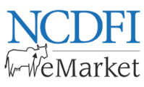**Suppliers Invited**

The Punjab State Cooperative Milk Producers’ Federation Ltd, Chandigarh is interested to enter into annual rate contract for purchase of Packaging Materials i.e. Ghee Tins 15 Kg & Ghee Mono / Ceka Cartons for Packing of Ghee for its different units/unions through e Auctions at NCDFI e-Market across Punjab from 03:00 PM to 5:00 PM on 20.07.2023. Interested suppliers/vendors are invited to register and participate in above said e-auction through [www.ncdfiemarket.com](http://www.ncdfiemarket.com) portal.

**For registration:**

Contact: + 91 9998019608; +91 9978601585

e-mail: [contracts_pack@ncdfiemarket.com](mailto:contracts_pack@ncdfiemarket.com),

[Virender.choudhary@neml.in](mailto:Virender.choudhary@neml.in), divakar.juneja@neml.in.